New Phonics and Spelling Rules  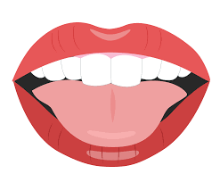 In Spanish, ‘z’ is pronounced ‘th’: voz / diez the ‘s’ is almost always soft: dos, tres, seis ‘rr’ is a common sound in Spanish: perro and burro ‘o’ sounds like ‘o’ in ‘not’ (not like oa in boat): ocho  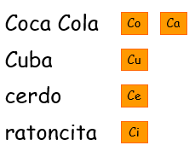  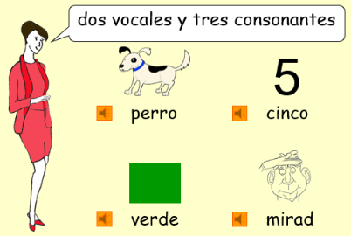  In Spanish, the ‘c’ is hard when followed by a, o and u.  The ‘c’ is soft (like th in thimble) when followed by e and i  Just like in English, in Spanish, we can differentiate between vowels (vocales) and consonants (consonantes)    Usually, the penultimate syllable in a Spanish word is emphasised eg: Gra -na-da. However, if there is an accent, the accented syllable is emphasised: Má – la - ga, Cas -te – llón, Cór-do-ba. |  | New Conversational Phrases  We can wish somebody  We can ask somebody what they would like.  a Happy New Year:  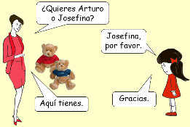  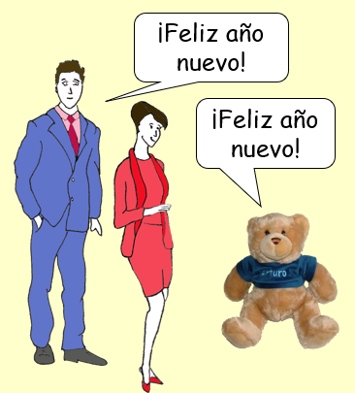
  New Vocabulary and Phrases  En voz alta 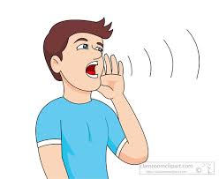  En voz baja     once doce trece catorce quince  un caballo un cocodrilo un tigre un cisne una araña una paloma |  | 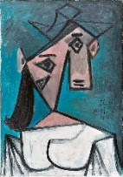    Cultural Knowledge  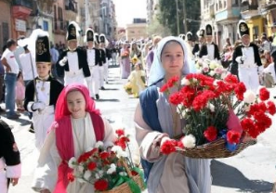  Different Spanish speaking countries have their own traditions for celebrating Holy Week – Semana Santa.  Pablo Picasso is a famous Spanish artist.  La Alpujarra is a mountainous region in Andalucía.
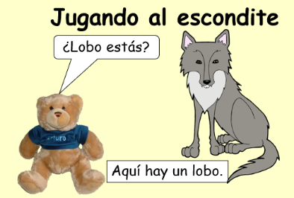
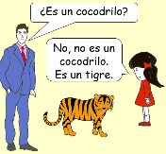
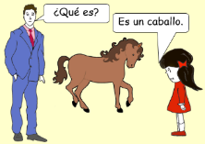
New Grammar Points and Sentence Structures
In most languages apart from English, nouns have a gender. Nouns are introduced by different determiners depending on whether they are masculine or feminine. A determiner introduces a noun in a sentence. The equivalents of the English determiner ‘a’ or ‘an’ are ‘un’ for masculine nouns and ‘una’ for feminine nouns.

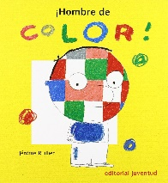  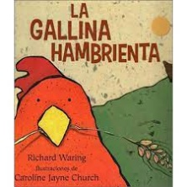  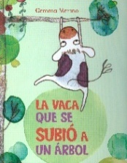  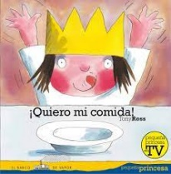  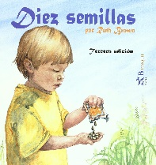  Books | 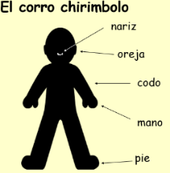  Songs and Finger Rhymes  A mi burro;  El corro chirimbolo (circle dance)  Los pajaritos  Juan Pequeño baila.

