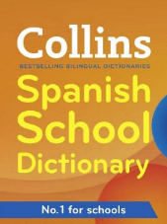  New Phonics and Spelling Rules  In a bi-lingual dictionary, we identify the class of a word using this code:  After a noun, the letters m / f / pl show whether the noun is masculine, feminine or plural.  We can change some nouns from a masculine noun to a feminine noun by simply changing the final letter from an o to an a.  A ‘d’ at the end of word eg tengo sed is soft – it sounds like the ‘th’ in bath. |  |  | New Conversational Phrases  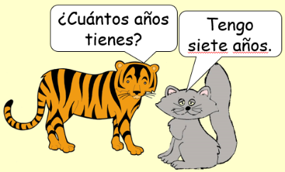  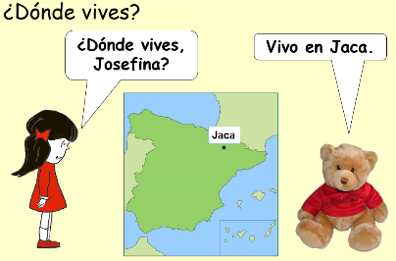  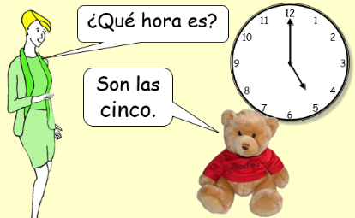
  n | vb | pron | adj | adv | conj
  noun | verb | pronoun | adjective | adverb | conjunction
  Masculine | Feminine
  amigo | amiga | friend
  hermano | hermana | brother /sister
  abuelo | abuela | grandad / grandma
  tío | tía | uncle / aunt
  chico | chica | boy / girl
  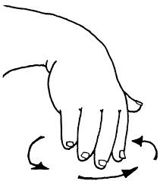 | ga | go | gu
   | gato | golf | me gusta
  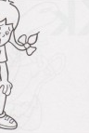 | gi | ge
   | girasol | gente
   |  |         
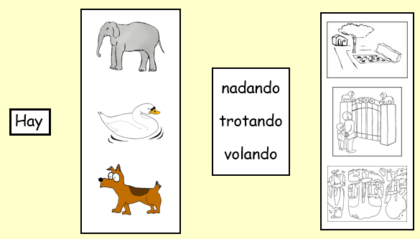  New Grammar Points  Adjectives change to agree with the noun gender and plurals:  Adverbial phrases in different positions in a sentence. |  |  | New Vocabulary and Phrases  ¿Qué te pasa? = What’s up?
  Masculine | 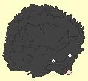 | 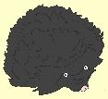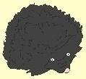
   | un erizo negro | dos erizos negros
  Feminine |  | 
   | una araña negra | dos arañas negras
   |  | 
  Tengo hambre. | Tengo sed. | Tengo sueño.
  tengo = I have
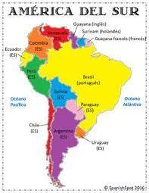
Cultural Knowledge
Spanish is spoken in many South American countries
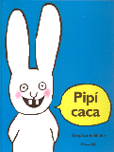  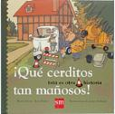  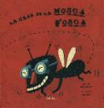  Books | Songs  Mi gallo  La tía Mónica  La pulga de San José  San Severino | 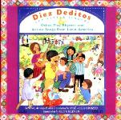  Finger Rhymes  Pulgarcito  Mi familia  Vamos a cantar

