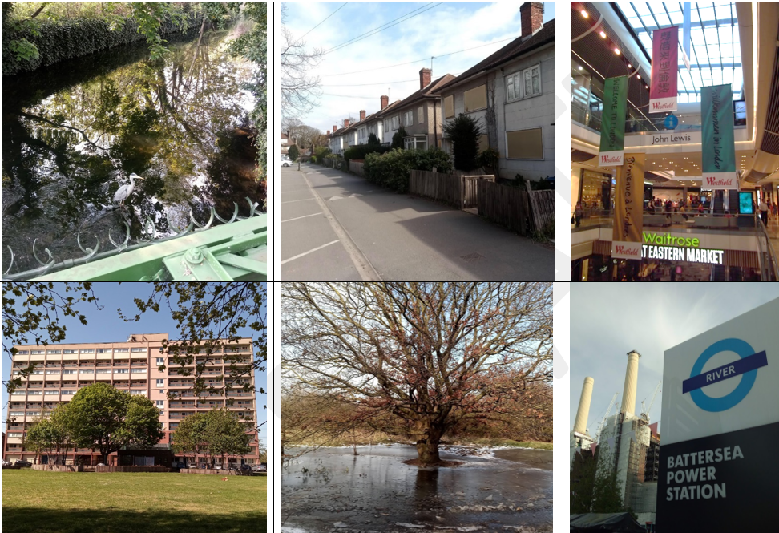
Important things to know
- Our settlement is our home: where we live; where people work and play.
- Local landscapes might be grey, green or blue.
- Grey places include playgrounds, car parks, streets and pavements.
- Green or blue places describe trees, gardens, rivers, streams, ponds and the sea.
- You might even have a coast, hill or a mountain near you!
- Landmarks are important locations where people celebrate, gather or commemorate events. Our school is also a landmark!
- Homes can be flats; detached or semi-detached houses; or bungalows.
- Nearby, there might be places to buy things or get things fixed.
- What shops, High Streets, retail parks, superstores or garages do you have? How far away are they?
- Ways of travelling include buses, trains, trams and cars. People may also walk on a pavement, footpath or bridleway, or they may cycle.

5 words to remember
home
landmark
near and far
school
settlement

Green locations include rivers and parks | Grey locations include streets | Shops and supermarkets are where we buy things
Homes are where we live | Parks and gardens are where we relax and walk our dogs | Landmarks sometimes change how they are used; travel is how we get around

