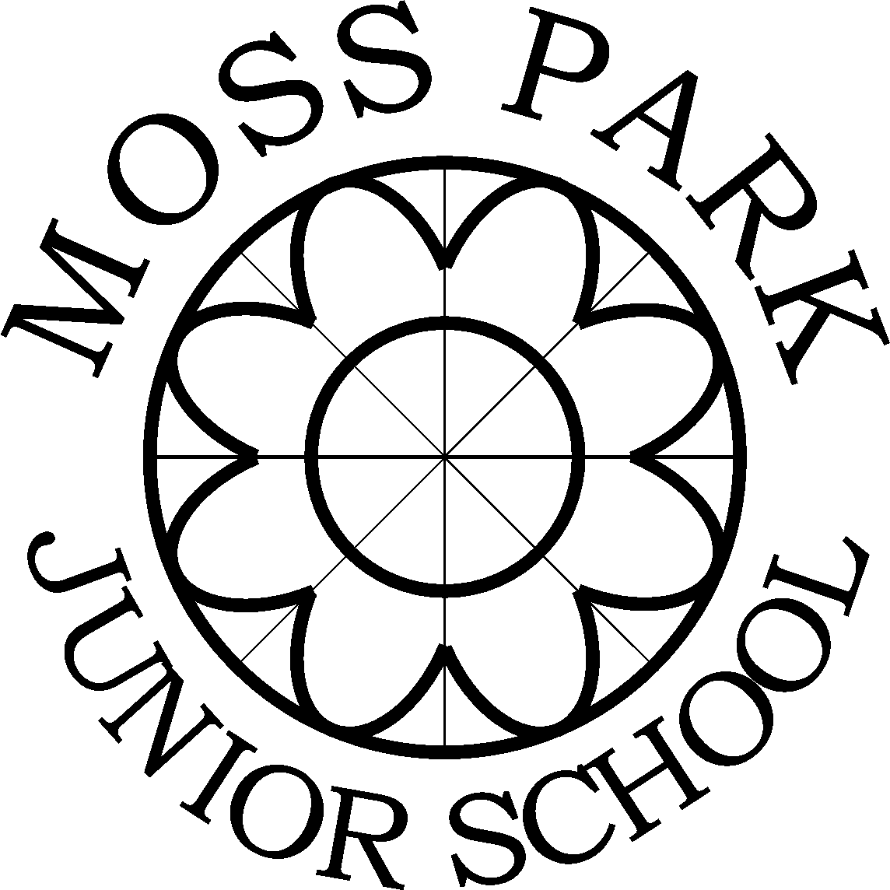

Learn, Respect, Achieve

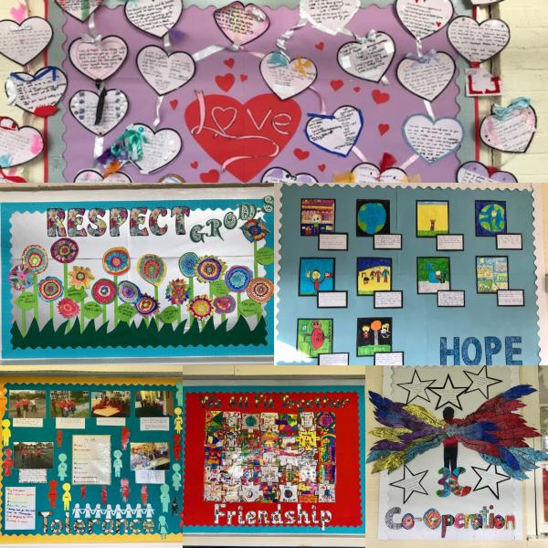

School Brochure 2020 – 2021
Please note that items in purple are changes made after the Government covid guidance on full opening of schools.

Introduction

Firstly let me start by saying thank you for choosing Moss Park Junior School for the next stage of your child’s education. I look forward to a long and successful relationship with you and your family.

Moss Park Junior School was built in 1930 and is situated in an area of private housing, next to Moss Park, in Stretford, Manchester, in the borough of Trafford.

The children have access to a large playground and surrounding, enclosed playing fields. There is a separate games field for football, rounders and other team sports.

The school is built around two attractive quadrangles. The smaller quad belongs to the Junior School and the larger one is shared with Moss Park Infant School. The children enjoy outdoor learning and also helping with gardening.

The school is a two form entry mixed junior school and caters for children from 7 to 11 years. The staff are committed to ensuring that high academic, behavioural, social and moral standards are achieved by creating a caring, secure and stimulating environment, where each child is provided with a wealth of learning experiences in a broad and balanced curriculum.

Our school is committed to working together with parents and their children to ensure that our pupils are offered only the highest educational opportunities. We are proud of our relationship with the local community and of the reputation we enjoy within it.

The following information sets out the aims and values, organisation and various activities of the school. It shows how parents and carers can participate in the life of the school and help their children to derive the maximum benefit from this period of their education.

Confidence in school comes from knowing and understanding what is happening within it. If you have any questions or you would like to find out more about any aspect of school life, please do not hesitate to contact me.

Kind regards,
Sally Nunwick
Mrs S Nunwick
Headteacher

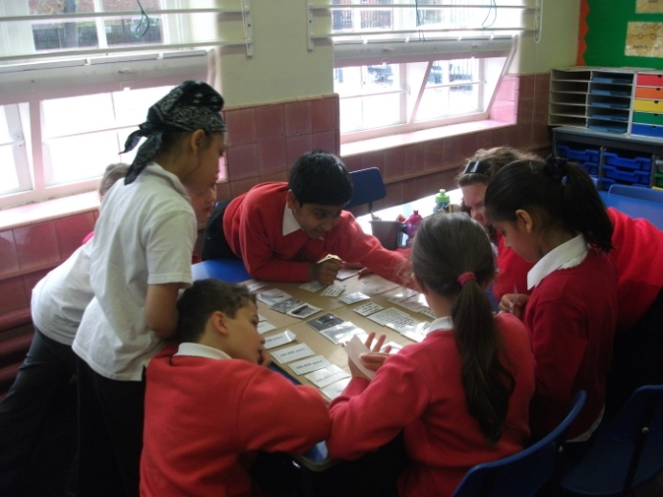
Members of Staff September 2020

Headteacher |  | Mrs S Nunwick
Deputy Headteacher |  | Mr R Boyer
Special Educational Needs Coordinator |  | Mr Boyer is acting SENCo this year (maternity leave)
Teaching Staff
 | Year 3J | Miss N Jones
 | Year 3TM | Miss C Thompson -Morgan*
 | Year 4R | Miss M Rice*
 | Year 4T | Mr C Tarry
 | Year 5H | Mrs K Horvath
 | Year 5A | Miss M Axon*
 | Year 6I | Miss A Isbister
 | Year 6B | Mr R Boyer/Mrs Butler
 | Support Teacher  Support Teacher/SENDCo | Ms J Butler  Mrs A Foster
Teaching Assistants |  | Mrs P Threlfall
 |  | Mr J Ward
Miss M Brown
Mrs L France
Mrs R Singh
Mrs S Hilton
Mrs S Woods
Business Manager |  | Mrs S Moroney
Administrative Support Assistants |  | Mrs J Willett  Mrs K Fielding
School Site Manager |  | Mr J Irvine
Lunchtime Welfare Assistants | Supervisor | Mrs P Threlfall  Mrs S Vaughan
 |  | Miss M Brown
 |  | Mrs Wahid
Mrs P Kaur
Miss E Spencer
 |  | Mrs E Johnston
 |  | Mrs K Woods
* Maternity leave cover for the academic year - Miss McEvoy, Mrs Edwards and Mrs Foster.

School Governors

The Governors have the overall responsibility for the effective management of the school, including financial control and budget planning.

The Governing Body is made up of twelve members, who each serve for a period of four years. They meet 4 times a year as a whole body, and are split into two committees – Curriculum Standards and Welfare and Resources & Premises. These two committees also meet three times a year. Mr Allan Humphris is our Chair of Governors and he can be contacted via the school office.

The Present Governing Body of Moss Park Junior School

Name | Office
Mrs S Nunwick | Head teacher
Mr A Humphris | Co-opted (CHAIR)
Mr S. Ayodeji | Co-opted (Vice Chair)
Miss K Higson | Staff
Mrs P Threlfall | Staff
Mrs B Dirikis | LA
Mrs M Aljaizani | Parent
Mr O Khan | Parent
Mrs S Bennion | Co-opted
Mr R Boyer | Observer (Deputy Headteacher)

Moss Park Junior School Aims

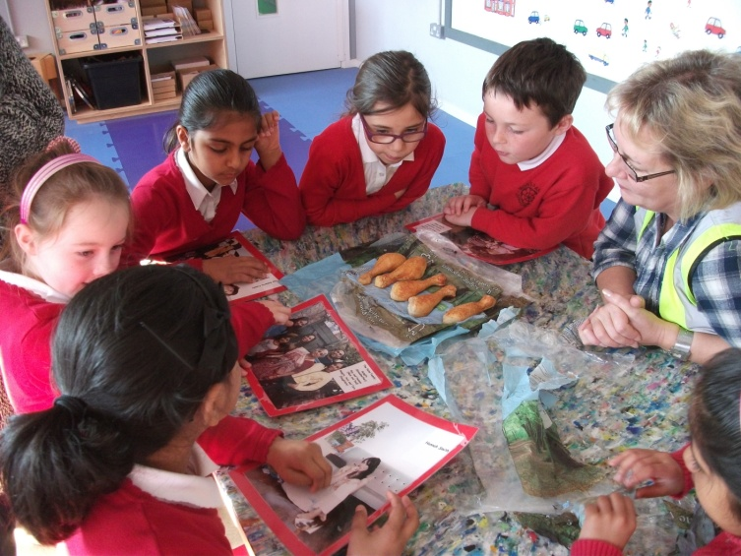

- Provide a welcoming, safe and stimulating learning environment
- Recognise the individuality of all pupils and provide for their particular needs
- Equip pupils with the skills and values they need to form positive relationships based on equality and mutual respect
- Enable all pupils to reach the highest possible academic standards and fulfil their potential
- Foster a love of learning that will continue throughout our pupils’ lives
- Build strong partnerships between school, home and the community

Our School Values

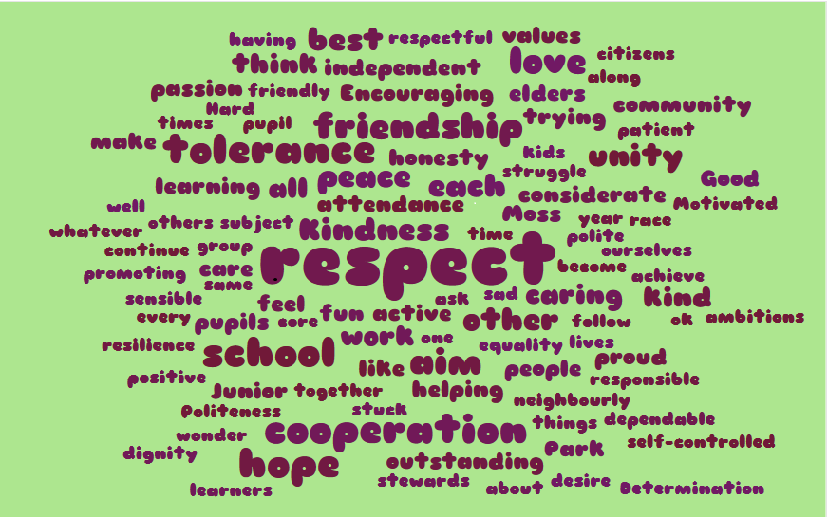

A core set of values were chosen by all the pupils and we focus on these values in our assemblies, when discussing our expectations of behaviour and to promote positive relationships. These values are woven into our curriculum and all aspects of school life. They are:

Tolerance, Cooperation, Kindness, Friendship, Respect, Love

Admissions Arrangements

Parents wishing to seek admission to this popular school are invited to contact the Headteacher who will explain the Admissions Policy operated by the LA on our behalf, including information on arrangements for the admission of pupils with disabilities. In-year admissions to our school are handled by Trafford Admissions Team.

Coming to school

The gate to the school playground is opened at 8.40 am when school starts. The playground and playground gate is supervised by a member of staff on a rota basis so that you can ‘drop and go’. Always drop your child off here first before their brother or sister in the Infants to avoid your junior child being late. Please leave any messages for teachers with the staff member on gate duty and they will be passed on via note pad. We cannot ask teachers to leave their classes to speak to parents. Parents are allowed in school by pre-arranged appointment only (DFE guidance). This year pupils will go straight to their classrooms to do pre-learning activities on arrival regardless of weather. Children should not arrive earlier than 8.40 am unless they are attending Breakfast Club as we do not supervise pupils before this time. Parents and pupils must not stand around at the front of the school waiting to be let onto the grounds as we should avoid gatherings in small spaces.

We regularly have some problems with car parking, particularly at home time and have been reminded by residents living opposite the school to ask parents to refrain from parking across their driveways. Parking on the zig zag lines outside school and across the school gates should also be avoided for the children’s safety. Parents should park away from school and walk so that we do not have tailbacks of cars on Moss Park Road.

Key Times

From 8.40 am pupils in Years 3 and 4 enter via the Lower School playground door, Years 5 and 6 enter through the Upper School playground door at the rear of the building. All our doors are supervised by members of staff. The gate is locked at 9.00 am. If you arrive after that time your child is late for school and will receive a late mark in the register. Latecomers should enter through the front school office, where they will have to be signed into the late Book.

The register is taken at 9.00 am. Children not in classrooms by the time the register is taken are marked Late. Children who arrive after 9.30 am are given a ‘late after registers close’ mark, which counts as an unauthorised absence. The school monitors the number of late marks a child receives and will notify Trafford’s Educational Welfare Officer of any concerns.

The school day is normally organised as follows:
8.40 am Start of pre-learning activities
9.00 am Session 1 (including assembly)
10.20 am – 10.30 am Morning Break (this will vary due to the new Government guidance)
12 Noon – 1.00 pm Lunch Time(this will vary due to the new Government guidance)
1.00 pm Session 3
2.10 pm – 2.20 pm Afternoon Break (this will vary due to the new Government guidance)
2.20 pm Session 4
3.20pm – 3.40 pm School finishes (Time for your child TBC due to the new Government guidance)
The End of the Day

The gate to the playground will be opened at 3.15 pm and you are able to wait on the playground (each year group has a zoned area - map to follow!) for your child – please observe social distancing guidance.

Children will be dismissed from 3.20 pm, starting with our children who have permission to walk home on their own and our youngest pupils in Year 3 and Year 4.
We will use a walkie talkie system to get children promptly out to you. Please make an appointment during the day via the office if you wish to speak to a teacher as we must safely supervise pupils leaving school as a priority.

Pupils in Y3 and Y4 are not allowed to walk home on their own unless they are with a sibling in Y5 and Y6 and the ‘Walking Home permission form’ has been filled in for all siblings. Please collect your Infant child first then come round to our playground. Parents will not be allowed to collect their children from the shared space in front of the two school offices for safety reasons. Gates are shut at 3.40 pm promptly.

All children are taken to the school office in the event of the appropriate person not being there to meet them by 3.40 pm. Parents and carers who are late need to sign their pupil out in the ‘Late Pickup’ book. Parents and carers are requested to ensure their child is collected on time please.

Additionally, if the nominated person to pick up your child is under 16, then you must have provided written permission for this to take place – this will include a contact mobile number for them.

Moss Park Junior Breakfast Club

Our Breakfast Club has been running for over ten years. It operates from 8.00 am to 8.50 am and costs £2.20 per child, per day. Toast and a variety of cereals, juices and a drink are served each morning. Pupils who are in receipt of the Pupil Premium grant have free places. The children are closely supervised whilst they eat and then play with toys and games and taken to line up with their classes at 8.50 am. We also accept Moss Park Infant School children (not Nursery pupils) who are escorted by staff into the Infant school when the Club ends. At the moment there is no need to book in advance: just turn up and enjoy!

‘KOOL Kidz’ is an after-school club for both our Junior pupils and the Infant pupils ran in the adjoining Infant School. Contact numbers: 0161 864 3636 or 07495 921416. Information can also be obtained from the Moss Park Infant School office.

Communication

We use the Teachers2parents text messaging service to communicate quickly and easily. We also use parentpay for letters & emails – so please ensure that we have an email address for you.

Confidentiality

We comply with government requirements with regard to confidentiality. The files we keep on children are open to parents. Information from third parties will not be disclosed without their prior consent. Access to these files may be withheld in certain prescribed cases where there are instances of actual or alleged abuse. Working notes are not subject to disclosure, but will be summarised and then kept on file.

Attendance and Absences

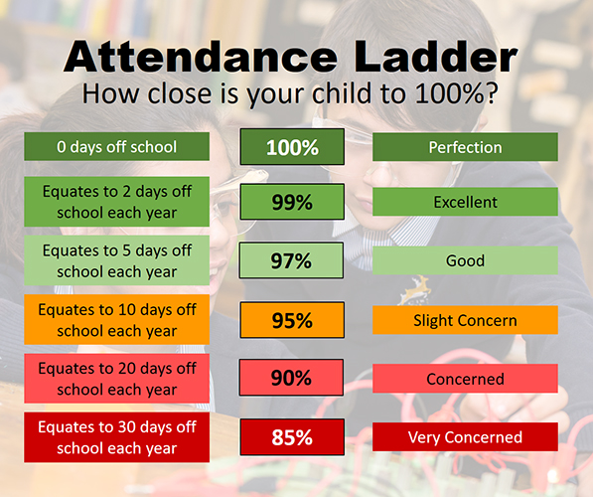

In the case of sickness or medical appointments, we request that parents let us know of the child’s absence as soon as possible by telephone, in person or by letter. We are very grateful to all our parents for their co-operation in this matter.

Changes to the Education (Pupil Registration) (England) Regulations 2006 came into force in September 2013. The changes include Headteachers no longer granting pupil holidays in term time. The statutory threshold of ten school days leave of absence has also been removed.
Parents will be fined by the Local Authority for taking their child on holiday during term time without consent from the school. Consent for absence can only be given in exceptional circumstances. At Moss Park Junior School exceptional circumstances will be decided by the Headteacher, following an interview with the parent or carer. The exact wording from the DfE can be found at www.education.gov.uk/schools/pupilsupport/behaviour/attendance/a00223868/Regulations-amendments
We have enclosed a copy of our Attendance Policy with this School Brochure.
Medicines in School
For health and safety reasons, medicines are not routinely given at school. However, a Request to Administer Medication Form may be completed by the parent in special circumstances, such as an ongoing course of antibiotics. Arrangements should be made with the Headteacher. The school is always prepared to make reasonable adjustments, for instance, in the case of long-term illness e.g. epilepsy, diabetes or conditions requiring Ritalin. Pupils must never keep medicines with them.

Pupils requiring long-term medication will need to have an Individual Health care Plan drawn up. This will be with the agreement of the Headteacher and may involve the School Nurse. In the case of asthma, inhalers are kept in the pupil’s own classroom and should be clearly labelled with the child’s name and the dosage. Children are expected to administer their own inhalers.

It is the parent’s responsibility to ensure all medicines are up to date and that the school has adequate supplies of medicines for long-term conditions such as diabetes, asthma and severe allergies. Throat lozenges can be a choke hazard so we request that they are not sent into school please.

Health and Welfare

It is essential that we have a current home and/or work address and telephone numbers in order to contact you should an emergency arise. When your child starts school we will ask you to complete a contact form so that we have this information. If you change your address or telephone number please inform school immediately.

A copy of the school’s Supporting Pupils with Medical Needs and First Aid Policy can be obtained from the school upon request.

Accidents and Illness

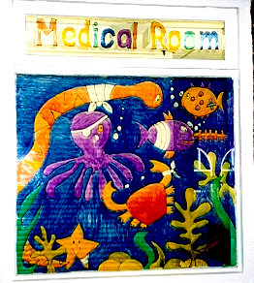

In the event of a minor injury or if a child should be unwell at school then action will be taken. It may be that a little first aid (cold compress) and sympathy is enough, in which case this will be dealt with by the staff. In the case of a head injury or more serious accident, parents or carers will be contacted immediately in order for them to ascertain whether the child should remain in school. Parents/carers will be contacted either at home or at work. It is for this reason that emergency contact numbers must be accurate and up to date.

The school has a dedicated Medical Room, which is quiet and fully fitted out with medical supplies and a locked but accessible cupboard for storing medication. It even has a bed! Our staff make caring for our pupils their highest concern.

Seven members of the school staff have the full and up to date First Aid at Work/Paediatric First Aid qualification and basic first aid training is part of the continual professional development for teaching and non teaching staff in the school.

Emergency contact forms are sent to parents to complete annually, in September. When circumstances change parents are requested to inform school immediately, please.

A copy of the Governors’ Health and Safety Policy is available upon request.

Dinners and Packed Lunches

At lunch time children may have a school dinner. These are delicious and are cooked in the kitchen which is situated in Moss Park Infant School. Some children bring their own packed lunch.

Dinner money, which will be £11.25 per week, from 1st September 2020 and is paid on the ParentPay system.

Please note that if your child is on School Dinners and they wish to start bringing in a packed lunch, they need to give a minimum of a week’s notice as the School Cook orders our food on Monday for the following week.

Children bringing a packed lunch should have a suitable lunch box in which to bring their lunch and keep it fresh through the morning. Drinks should not be fizzy and no glass bottles please. We do not allow chocolate/chocolate bars or sweets in packed lunch boxes. Children should bring their own spoons for yoghurts etc.

If a child is to go home for lunch they must be met by a responsible adult at 12.00 noon promptly and returned to school by 1.00 pm. Children should not be brought back to school before 12.50 pm. There are no school crossing patrols on duty any more therefore it is the responsibility of parents/carers to ensure that children are seen safely across the road.

In order to maximise the funding the school gets, it is essential that parents whose children are/may be eligible for free school meals are registered with the Local Authority, whether they take the meals or not. The school receives extra funding dependent on free school meal entitlement of approximately £1300 per child and by registering, parents can support our school in this vital area. Information can be obtained from the school - please do not hesitate to ask us for advice.

Snacks and Drinks

The children may bring snacks for break times. Snacks should be healthy: fruit, crackers, cereal bars (no icing or chocolate), raisins etc. Sweets, crisps, biscuits and chocolate are not allowed at morning and afternoon break times and cans of drinks and chewing gum are not allowed at any time.

Water is freely available all day from the water fountains (please note that we may have to keep these covered – watch this space) and the children may have water bottles in their classroom with them. These bottles should be clear plastic, not too big and named. They should be filled at home with water only, please, before school and can be refilled during the day from the water cooler, which is accessible to all children.

When children celebrate a birthday, parents sometimes supply the class with chocolate or sweets. We relax our rules on such special occasions but ask parents not to send in lollies or other sweets, which have a stick attached. The school has been accredited as a “Healthy School‟ since the Autumn Term 2006.

Money and Security

Children are discouraged from carrying money in school. We ask that money for donations, PTFA events etc. is sealed in an envelope, marked with the child’s name and class, the amount and purpose. In this way, money which is lost in school can be more readily traced and returned to the child. Payment for trips etc are to be made on the ParentPay system.

Similarly, children are actively discouraged from bringing in toys and games, jewellery or ‘precious’ possessions. The school cannot be held responsible for the safety of such items and we do not want a child to lose or break a special possession whilst in school. The children are not allowed mobile phones in school at any time without express permission for walking to/from school. There is a request form for this – but this is only used if children are walking home alone.

School Uniform

“Our school uniform is important to us. It is one way in which we identify ourselves as a school community and it promotes a strong, cohesive school identity that supports high standards and expectations in all areas of school life. It promotes harmony between different groups represented in the school, and it enhances security.” (Moss Park Junior School Uniform policy 2019)

Parents are requested to follow the school’s dress code when buying school wear for their children. We are constantly striving to raise standards and part of this drive is to ensure that our pupils are dressed appropriately and smartly for school. We want our children to wear their uniform with pride. John McHugh in Stretford Mall stocks all our uniform with the logo on.

- Red sweatshirts or cardigans (plain or school logo)
- White school shirt
- School tie (compulsory from September 2020)
- Black or grey skirts, culottes, pinafores or trousers or plain black/grey shorts (in the summer)
- Red and white striped or checked dresses (in the summer term and 1st half autumn term)
- Red polo shirt (plain or school logo) in the summer term and 1st half term in autumn
- Black shoes with a flat heel*. NOT trainers or knee/heavy boots, please
- Long hair should be tied back off the face using hair accessories in black, brown, metallic silver/gold, grey, white or red (no huge bows/’cats ears’ type fashion headbands)
*Many shoe shops stock black school shoe/trainer crossovers for boys. If a black trainer has a white or coloured sole going round it and/or decoration it is a sports trainer and is not acceptable as school uniform
PE Kit

- White t-shirt (Proper PE shirt with logo is stocked in John McHugh)
- Plain black shorts, PE skirt or leggings/plain black or grey jogging bottoms
- Trainers for outdoor PE
- Black, grey or navy tracksuit or sweatshirt for outdoor PE in the colder weather

No football strips please. All kit needs to be labelled and stored in a named PE bag. We strongly suggest that PE kit is kept in school for the half term and taken home then for washing. This minimises the amount of times pupils have to remember to bring things in.

All children will require a coat in cool weather/winter and a school bag (not a large sports bag please) to carry their reading books, letters home, homework etc.

Jewellery
A watch, one pair of stud earrings and/or a religious symbol that is considered an essential article of faith, (which should be tucked safely out of sight under uniform), may be worn. We follow Trafford’s Health and Safety guidance regarding jewellery during PE and swimming which states that no jewellery should be worn. With this in mind, ear piercing should be done during the first week of the summer holiday so that your child does not have to miss their PE lesson. Teachers are not able to remove or put in earrings for pupils.

Clothing and Items of Religious Significance

- Head coverings worn for religious or cultural purposes should be in plain red, black, grey or white and must be short/bale to be tucked in and must not use pins as fixings
- Any jewellery worn for specifically religious reasons, such as a kara, should be limited to one item, and should be removed for PE for health and safety reasons or covered with a sweatband.

N.B. We are no longer using separate ‘book bags’ in school – they are too big for the trays and there is simply not enough room on the corridor cloakroom pegs for a third bag

Curriculum Provision

The curriculum in its full sense comprises all the opportunities for learning provided by the school. It includes the formal programme of lessons, extra-curricular and out of school activities that are planned and supported by the school and the climate of relationships, attitudes, styles of learning and behaviour established in the school community as a whole.

Moss Park Junior School has been awarded the Basic Skills Quality Mark 4 times, School Games Mark Silver, Arts Mark Gold, Geography Mark Silver, International School Award and we are an Eco Green Flag School. The development of Basic Skills in Mathematics and English is given priority across all year groups. Science, History, Geography, Art, Computing, Design Technology, Music, PE, PSHE, RE and Spanish are taught discretely but links are made between subjects throughout topics. We teacher is taught discretely and applied across the curriculum. The school aims to offer pupils a broad, balanced and coherent curriculum encompassing both the legal requirements of the 2014 National Curriculum and a wide range of activities that we believe are important to the development of children regardless of gender, age or background. Enhancement through Art Days, Visits, Community Projects and ICT development is a feature. Please visit our website for more information.

Each year group’s long term curriculum plan is on the school website. Each half term your child will receive a topic web, which will also be on your child’s year group page on the website.

Other activities, which are taught to all year groups, cross subject boundaries and include Environmental Awareness, Economic and Careers Education, Philosophy 4 Children, Homework Support and Personal, Social, Health Education. Please see our website for further information.

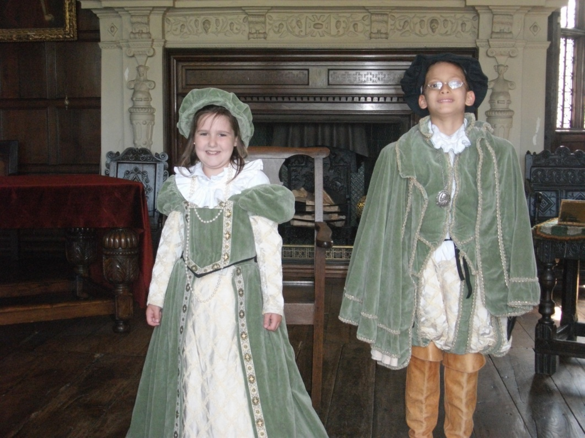

Teaching

At Moss Park Junior School we employ a balance of teaching methods and the teaching staff plan for a variety of teaching and learning experiences for the children. We strive for excellence through enjoyment and curriculum enhancement is a feature of the school.

Classes may be taught as whole groups, in small groups or as individuals depending on the activity or environment required.

All staff regularly attend training to improve and enhance their skills and to ensure our school offers the highest quality education and care for its children.

Assessment and Testing

Children’s progress in school is regularly assessed by their teachers. This assessment is a vital element in the planning of lessons and the curriculum. It contributes to all stages of the child’s learning.

The school also employs a variety of verbal and written tests which allow us to assess potential against achievement and provide the school with detailed assessment data. This, in turn, allows us to set informed targets for the school year. Targets are set for cohorts (year groups or individual classes) groups of pupils and for individual children.

We use a commercial assessment system called Target Tracker and judgements on attainment and progress are systematically made in order to let pupils, parents and teachers know how well the pupils are doing and the next steps in learning for individual pupils and groups of children.

All children are assessed throughout the year. The children in Years 3, 4 and 5 take end of year tests in the summer term. Under the present requirements of the National Curriculum children in Year 6 are formally tested at the end of Key Stage 2, in May. The results of these tests are reported to parents and published on our Website.

Exams for individual Grammar Schools are taken in the autumn term by Year 6 pupils. Information is distributed by the LA to parents of pupils in Year 6 at the start of the academic year regarding secondary school selection preferences.

Reporting to Parents

At Moss Park Junior School we actively encourage parents to come in to school to discuss any problems or concerns. We will always endeavour to make an appointment for parents to meet with the Class Teacher or Headteacher at short notice if it is felt there is a problem or the child is unhappy for some reason.

Formal Parents’ Evenings take place three times a year, autumn, spring and summer and written reports, detailing the child’s progress in all areas of the school curriculum are issued to parents at the end of each academic year. Interim Assessment Summaries from Target Tracker are shared at the autumn and spring Parent’s Evenings.

Good communication is at the heart of the school’s ethos: it ensures a successful partnership between home and school.

Religious Education

Moss Park Junior School is a Community Primary and statutory Religious Education is followed in accordance with the agreed syllabus of the Local Authority.

The Education Reform Act, 1988, requires all schools to have a curriculum which promotes the spiritual, moral, cultural, mental and physical development of pupils. It must prepare pupils for the opportunities, responsibilities and experiences of life and it must include Religious Education for all pupils.

Religious Education requires the development of concepts, skills, positive attitudes and respect for other peoples’ beliefs. It has an important role to play in helping us to form a positive school ethos, where all are valued and respected. Religious Education is taught to all year groups across school for the equivalent of one hour per week. We do not teach a particular faith position but an understanding of the interrelationship of faiths and beliefs.

A requirement of the Act is daily collective worship. The law in England and Wales requires that most acts of collective worship should reflect the broad traditions of Christian belief. At Moss Park Junior School we incorporate assemblies and worship which vary from simple gatherings and individual class worship to whole school and more complex occasions which may involve the work of the children or visitors.

Parents have a legal right to request that their child be withdrawn from lessons in Religious Education or from acts of collective worship (assembly). This is done in consultation with the Headteacher. We do not have any pupils currently withdrawing from RE or Assembly, which we feel is due to our inclusive curriculum and shared values.

Sex and Relationships Education

The school includes Sex and Relationships Education and Drugs Awareness as an integral part of the thematic work on growth, health, hygiene and fitness in Years 5 and 6. Sex Education is delivered in the context of family life, loving relationships and respect for others. The School Nurse supports and delivers our sex education curriculum. Governors have produced a policy statement on Sex and Relationships Education.

A copy will be available to parents upon request from September 2020 after parent consultation.

Equal Opportunities

The school is committed to equality of opportunity in education and to good relationships with those of all racial, cultural and religious backgrounds. We are committed to challenging discrimination and promoting equality at all levels and in all aspects. We seek to celebrate the cultural diversity present in our society and our school. This school will not accept any acts of discrimination and will fully implement its Racial Harassment Policy.

Copies of our Single Equality Policy are available upon request.

Provision for pupils with Special Educational Needs and Disabilities

To ensure that every child enjoys equal opportunities and to prevent disabled pupils being treated less favourably than other pupils, we constantly audit and monitor our provision, including the curriculum, building, environment and additional activities and services.

The Equality Act 2010 provides a single, consolidated source of discrimination law and replaced all existing equality legislation. The Disability Equality Duty (DED) is not only about changes to buildings or making adjustments for individuals, it is about weaving equality for disabled children and adults into the culture of schools in practical ways.

At Moss Park Junior School we aim to maximise social inclusion by removing barriers to achievement for disabled pupils and staff. We endeavour to promote disability equality, eliminate discrimination and harassment, promote equality of opportunity, encourage participation by disabled people, promote positive attitudes to disability and ensure steps are taken to take account of disabled people's disabilities, in all aspects of school life and the community.

The curriculum is broad and balanced. Differentiation to meet pupils’ needs is embedded in teachers’ planning. Developing high quality, appropriate resources and equipment, to meet the needs of all pupils, is an ongoing target in our School Improvement Plan. Visible, reachable displays and learning resources, as well as alternate ways of recording work, improve access and provision for all pupils. Policies and practice are evaluated to ensure all pupils can benefit.

The physical environment is constantly developing to improve accessibility for everyone who uses the building. Ramps, fire doors and wide, clear corridors provide access to classrooms and play areas. An accessible toilet has been installed off the entrance hall.

Copies of the Governors’ Accessibility Plan are available upon request.

Moss Park Junior School aims to enable pupils with additional educational needs to participate in all areas of school life to realise their potential by working together towards the removal of barriers and improving provision. The school’s systems support the revised Code of Practice for the special needs of children with, or without, a Statement. We have an effective policy which aims to ensure that children’s needs are identified early. These needs may be associated with learning, or may be physical, emotional or behavioural in nature. We believe working with parents to be an integral and essential element of additional educational needs provision. The needs of the children registered are met largely within the usual classroom setting, with assessment and special provision being made available by the LA for those pupils who meet the criteria established by the Authority. We make every effort to liaise closely with all our support agencies, and pass on information to the families of pupils concerned.

The school’s Special Educational Needs coordinator is Mrs A Foster. Mr Boyer is acting SENCO for 2020 – 2021.
The school’s Special Educational Needs governor is Mrs B Dirikis
Both Mr Boyer and Mrs Dirikis can be contacted through school.

Our Special Educational Needs Local offer document is available upon the website or by request.

Homework

All children are expected to extend their learning experiences at home. Working at home is of great value in completing and reinforcing work done in school and helps to establish the self-discipline of individual study. The school, in recognising the important role parents play in the educational development of their child, actively encourages a positive parent-teacher relationship, with the expectation that this partnership will instil and promote a positive attitude to school and schoolwork. We therefore see homework as an important element in the overall curriculum and the educational development of the child. After our successful summer term using Google Classroom for homework, our homework will be set via google classroom next year. All children receive a gmail account when they start with us and we will be running parent workshops and devices workshops in September.

Children are set regular homework tasks alongside spellings, tables and reading practice.

Homework will almost always be related to work in the classroom but if children are spending an excessive amount of time on homework or finding specific tasks difficult, it is expected that parents would contact school and request guidance from the teaching staff on the appropriate support for their children. If pupils have struggled with homework, they can come to Homework Club, which is on Wednesday and Thursday lunchtime and staffed by teachers,

The co-operation of, and liaison with, parents is very much appreciated by the school and is an important way for home and school to maintain a close and constant contact with the work that children are involved in.

Behaviour
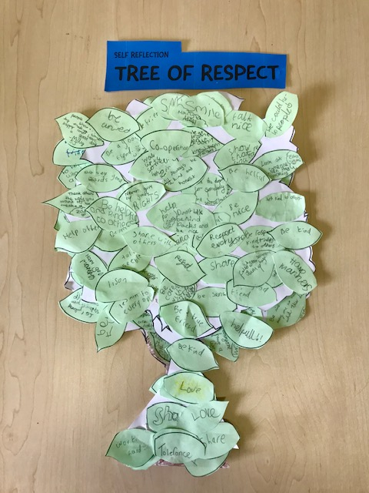

Moss Park Junior School has high expectations of standards of behaviour and the ethos within the school is based upon respect, consideration for others and working as a team.

This is the basis of our Code of Conduct, which is also our school motto:

Learn, Respect, Achieve

We refer to this Code of Conduct throughout the day and we aim to foster, encourage and support excellent relationships between all staff and children in the school. Persistent misbehaviour is referred to the Headteacher. We ensure that parents will be informed and involved. The latest Behaviour Policy Summary is enclosed with this School Brochure.

Extra-Curricular Activities

These activities range from judo, dance, athletics, singing (Young Voices), STEM, Multisport, Film Club and Art. We run our clubs in blocks of 10 sessions per term. We ask for a small contribution of 50p per session to go towards cover resource costs and pupils in receipt of the Pupil Premium grant are not charged. In Year 6 we have the very popular residential experience at Robinwood, in Todmorden. This outdoor activity centre provides exciting educational and adventurous opportunities for pupils to take part in canoeing, rock climbing, orienteering, archery etc. The visit develops teamwork and enhances the already positive relationships that exist between staff and pupils. All visits are subject to the advanced approval by the Governing Body and organised to comply with strict guidelines for off-site activities and LA and school policies on Health and Safety on Educational Visits.

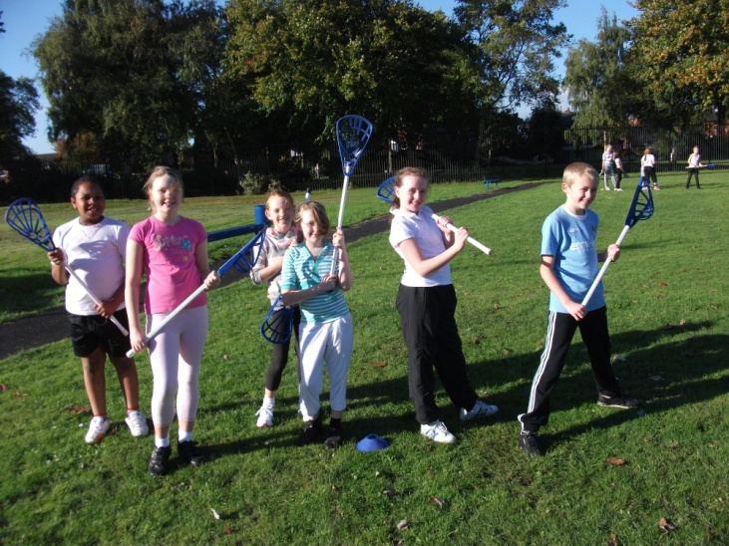

We enjoy enterprise projects and curriculum enhancement opportunities provided by our links within the community. The school is part of the School Sports Partnership and benefits from PE training for pupils, staff and extra-curricular sporting activities. Bikeability takes place for Year 6 pupils. We are always striving to provide more than just the statutory curriculum and with the extra-curricular activities that we have initiated for the children, we hope that we can broaden their experience, skills and knowledge whilst enhancing their fitness and health. Attendance at extra-curricular activities is dependent upon good behaviour.

Pastoral Care

Whilst the children are in school, the teachers act in loco parentis, acting as any responsible parent would. It is our aim to create a happy, caring environment where all children feel safe and secure. Children can approach their Class Teacher or any other adult in school that they trust. We provide quiet spaces for pupils to get away from the hustle and bustle of the playground should they wish and we have playground leaders and Buddies to support pupils. Sometimes we draw on outside agencies such as Longford Park, the School Nursing Team and other pastoral teams to support pupils and families. We use the Trafford Early Help guidance if we feel a multi-agency approach is needed. Registered First Aiders deal with the welfare of any child who becomes ill or injured and the Headteacher is informed. If necessary, the school will contact any parent or carer if we have a concern over a child’s health or welfare. If ever you feel your child is unhappy in school, or perhaps they have suffered a loss at home, we hope that you will feel comfortable in coming to school and talking to your child’s class teacher.

Links with the wider Community

Our pupils benefit from our close links with local Secondary Schools, who share their excellent resources, arrange joint creative arts performances, provide additional teaching such Food Technology and involve our pupils in exciting activities such as enterprise projects, sports events and Science, Technology.

The school benefits from very good links with sport groups like Manchester United, Lancashire Cricket Club and the School Sports Partnership. These allow our pupils to participate in inter-school competitions, intra-schools events, sports coaching and tournaments.

Close links and very effective transition arrangements with Moss Park Infant School ensure that children move up to us already familiar with their new teachers, classmates and school. Our Year 5 pupils act as Playground Buddies in the Infant School at lunchtimes.

A number of events are held in school to raise funds for local and national charities. Visitors talk to the children in assembly or lessons and links with local religious groups provide interesting activities to help our pupils to learn about others.

Provision for Sport in School

Children at Moss Park Junior School participate in a wide variety of sporting activities, both in and out of school time. Some of the sporting activities and coaching in school, available to our children, are lacrosse, cricket, dance, tag rugby, gymnastics and cross country running. Our football teams play league and cup games in the Stretford Junior Schools League and we are involved in Sale Harriers Cross Country meets, where our pupils do very well due to their ability to practice on the school’s own all-weather running track. The Schools PE and Sport Funding is used to impact upon healthy outcomes such as Change for Life activities, for which we won an award and coaching in specific sports such as tennis and tag rugby. All classes go onto our track or playground to do ‘1K a Day’, during social times and also during lesson time to make up the 5 sessions per week.

The school continues to provide swimming lessons for all children in Year 4 and these take place at Urmston Leisure Centre. Travel is by coach, with no charge to parents.

Parents in School

Parents are welcome in school to help with a variety of activities like baking, reading, accompanying classes on visits, computing and working with groups of children in Art and Craft or Design and Technology. If you can spare us a little of your time do let us know. By working together we can enhance the education we provide for our children.

Moss Park Junior PTFA

There is a thriving Parent, Teacher, Friends and Family Association who’s fund raising activities make a significant contribution to improving the school’s resources. Fund raising events include Family Discos, a Summer Fun Day, Bags2School, Family Nights and many more. All parents are welcome and become members of the PTFA on joining the school.

School Security

The security of our children is a very important issue. Staff, pupils and parents continue to be vigilant and all visitors are required to report to the school office before proceeding around school. A Visitors’ Book is maintained. Appointments can be made before or after school directly with the Headteacher, Class Teacher, by telephone, or in writing.

No Smoking Policy

The school operates a no smoking policy. This applies to all staff and visitors who use our premises both within and outside school hours. Parents are asked not to smoke anywhere on the school grounds or within the school boundaries. This includes the use of E Cigarettes on the premises.

Child Protection Procedures

The responsibilities for schools in the area of child protection are laid down in the Children Act, 1989, and the Education Act, 2002. The Keeping Children Safe in Education 2020 is the latest legislation and guidance and we regularly check that our school is compliant with this document. Day to day contact with children in school means that staff are well placed to observe changes in behaviour, failure to develop or outward signs of abuse. All staff receive training so that they can fulfil their responsibilities for child protection. The designated person for child protection in our school is Mrs Sally Nunwick, Headteacher. Copies of the Governors’ Safeguarding and Child Protection Policy and Safeguarding Policy are available upon request and can be found on our website.

Our Safeguarding Governor is Mr Alan Humphris and you can contact him via the school office.

Charging Policy

The school complies with the regulations for charging for school visits. Costs are kept to a minimum but for visits, and some extracurricular activities, we may ask for a contribution towards the cost. No child is ever refused a place on a visit or trip during the school day (8.50 am to 3.30 pm) because a contribution is not forthcoming. Parents are charged the full cost of residential visits that take place at weekends although payment for these may be arranged over a number of weeks or months. In addition we subsidise trips and visits for pupils who are in receipt of Free School Meals or who have been eligible for FSM in the last six years (The ‘pupil premium’).

A copy of the Governors’ Charging Policy is on our website and available upon request.

Complaints Procedure

At Moss Park Junior School we are proud of the very positive relationships we have with our parents. The vast majority of concerns and queries are dealt with promptly on an informal basis. It is, however, required that we have an established procedure for dealing with complaints, which is detailed below:

Under the provision of the School Standards and Framework Act the LA, in consultation with the Governing Body, has agreed a complaints procedure, in respect of the duties imposed with regard to a complaint about the curriculum and related matters. The process allows for sequential progress via the Headteacher, to the Governing Body, the LA, and ultimately to the Secretary of State.

A copy of the Governors’ Complaints Procedure is available upon request.

The above School Brochure information was correct to this document at the date specified in the document but it should not be assumed that there will be no change affecting the relevant arrangements or any matter particularised therein either, before the start of or during the school year in question, or in relation to subsequent school years.

Additional to this School Brochure you will find:

- Term Dates 2020 - 2021
- Attendance Policy Summary
- Behaviour Policy Summary
- School Uniform Policy
- Paperwork for you to fill in – it is really important that these are returned so that we can communicate with you electronically

Please note that you will automatically receive a copy of the Risk Assessment for Full Opening on 1/9/2020.

